***Tools and techniques for identification of threatened fauna***

Archana Bahuguna

Wildlife Forensic Laboratory and Molecular Systematic Laboratory, Northern Regional Center, Zoological Survey of India, 248 Kaulagarh Road, DehraDun, Uttarakhand 248195

Asian countries are rich in biodiversity and their biodiversity are targets of poaching. Poaching is one of the biggest illegal trade after narcotics and arms and ammunition. Mammals are the biggest target of poaching and they are killed for meat, hair, horn, antlers and many more products including ivory products, bile, claws, hair. Other crimes against wildlife include buying and selling protected animals and their products made from protected animals (UNODC, World Wildlife Crime report, Trafficking in Protected species 2020).

Molecular Systematic and Wildlife Forensic laboratory established in 2012 at Northern Regional Center, Zoological Survey of India, DehraDun, Uttarakhand worked on three major projects i.e. molecular study of 8 species of squirrels and 8 species of small cats listed under Wildlife Protection Act 1972, some species of lizards especially *Varanus.* To generate species specific sequences taxidermy samples were used as most of the species are rare and difficultto get the samples. The gene sequences (12SrRNA and 16SrRNA) thus generated, produced species specific sequences and submitted to NCBI and are being used as reference genetic material. Small mammals and *Varanus* are the major groups worked out to produce species specific gene sequences. Hair analysis is also a continuous routine work by the author to establish data for species identification.

**Mammals:**

**A) Carnivore: i) Felidae**: Big cats i.e tiger, leopard, snow leopard and clouded leopard in India are killed for preparing the fur coat (Fig. 5) from their skin and also for bones, claws, trophies and teeth. But in India as well as globally, many species of small cats are under threat due to habitat loss or habitat fragmentation, the collection and killing of felids for the pet and fashion trades (for fur coat), disappearance of natural prey and also due to cat human conflicts. According to the IUCN Redlist of Threatened Species, populations of 29 out of the 36 recognized species of felids are in declining trend and 5 of the remaining species are data deficient to determine demographic trends. In India there are 5 species of big cats and 10 species of small cats (Leopard cat, Pallas cat, Caracal, Rusty spotted cat, Fishing cat, Himalayan lynx, Dessert cat, Asiatic Golden Cat and Marbled cat).The study by using tichotaxonomy revealed that it is difficult to differentiate the species but molecular technique is the best way to differentiate the species (Figures 22, 23).

**Viverridae**: Civet poop Coffee costs $30 -$100 per cup. They are captured from the wild and caged in order to produce Kopi Luwak. The prices of Civet poop Coffee are justified by the claim that the coffee is sourced from wild animals which is extremely tedious to do. As far as use of civets in perfume industries is concerned it is known that the main sources of animal musk are the secretions of civet cats, beavers and musk deer. The global demand of the coffee which is produced in big quantity i.e. around 500 tons, for that they are caged in poor living conditions, they have to face mental and physical stress, leading to illness and death (https://www.globalgiving.org › microprojects › save-ci.).Among small mammals civets also called civet cat, a long bodied, short-legged carnivores of the family Viverridae (15-20 species, under 10 to 12 genera, distributed in Africa, southern Europe and Asia) were examined for trichotaxonomy (Figures 11-18) and it was noted by using this technique that it is difficult to identify the species thus it is essential to generate gene sequences for the group.

**iii) Herpestidae:**

**Threat from illegal wildlife trade:** Mongoose is largely threatened by the illegal trade of its hair that is used to make paint brushes. They are trapped and beaten to death so that their hair could be extracted for commerce. According to the Wildlife Crime Control Bureau (WCCB), India around 50,000 mongoose are killed for paintbrushes in India annually. It was also reported that the Grey Mongoose is captured and sold as a pet. They are also captured and killed for skin, which are then sold in local markets in Nepal. According to Wildlife Trust of India in 2002, about 50,000 mongooses were killed annually by poachers and the annual yield of mongoose hair was close to 1,000 kg (Deccan Herald, [/I] December 24, 2002). In India there are six species of mongoose found in India. The book was published dealing with small mammals. The study indicated that the species of mongoose can be easily identified by using hair analysis as the banding pattern is unique in species of mongoose

**Trade routes:** Mongoose hair is collected from Uttarakhand, Uttar Pradesh, Madhya Pradesh, Karnataka, Tamil Nadu, Kerala, Chhattisgarh and Maharashtra. There are traders working from Ghaziabad, Meerut and Kanpur in Uttar Pradesh, Nashik and Mumbai in Maharashtra, Delhi, Chennai in Tamil Nadhu and Siliguri in West Bengal among other locations. The export route includes Delhi, Mumbai, Ahmedabad and Kolkata. Lately, Indo-Nepal and Indo-Bangladesh routes have also been found lucrative by smugglers **(***http://indiasendangered.com/beware-your-paint-brush-might-be-made-from-mongoose-hair/* ).

**B) Rodentia: i) Sciuridae**: The family sciuridae consists of diverse group of species that have been the subject of numerous and important studies on behaviour, ecology, reproductive biology and morphology and play major role in evolution of forest and regeneration of forest. The squirrel family Sciuridae is one of the largest and most widely dispersed families of mammals, it comprised of tree squirrels, ground squirrels, chipmunks, marmots (including groundhogs), flying squirrels and prairie dogs amongst other rodents *(https://news.ufl.edu>articles>2018/01>why-should-you love squirrels*?.

But Squirrels are hunted, killed and their tails sold to the paintbrush industry. They are easy prey for old and weak poachers who lack energy to go after animals that require specialized skill to trap. At the outskirts of Bangalore, India, local people could be seen setting up small nets in mango and other fruit orchards. These nets are for catching these timid animals. Easily lured by nuts and food, poachers use calls to draw them near and when caught, their tails are immediately chopped off. Certain local tribes consume the meat but most often, the body is simply discarded. India Times reports that since the lockdown began due to COVID pandemic, there have been cases of Giant Squirrel poaching in Sawntwari in Maharashtra (*https://intothewildind.wordpress.com>tag>squirrel*.Florida wildlife officials accused seven people of capturing 3,600 protected flying squirrels and selling them overseas with estimated cost to be worth $1 million.

Extensive study done for hair for the species by the author revealed that the group has multiserial medulla (Figures 19,20) and based on cuticular one can differentiate flying squirrels from ground squirrels , but for delimiting the species the best approach is doing molecular study (Figure 24).

**C Lagomorpha**

The lagomorphs are the members of the taxonomic Order Lagomorpha of which there are two living families the Leporidae (hares and rabbits) and the Ochotonidae (pikas). The group comprised of 109 extant species (34 species of pika, 42 species of rabbit, and 33 species of hare). The Indian hare (*Lepus nigricollis*), also known as the black-naped hare, is a common species of [hare](https://en.wikipedia.org/wiki/Hare) native to the [Indian subcontinent](https://en.wikipedia.org/wiki/Indian_subcontinent)  and [Java](https://en.wikipedia.org/wiki/Java). There are 11 species of Lagomorpha in India. Hispid hare is an endangered species among all species under IUCN category and rest are least concern although *Ochotona roylei* , Royel’s pika is listed in Wildlife (Protection) Act 1972 under Schedule I. Seven species are present under *Ochotonidae* and four species under *Leporidae* (Hoffman.and Smith 2005; Suchentrunk and Mihajla 2004, Bahuguna 2015).It was noted that by using cross section of hair, it is easy to differentiate two families of Lagomorphs and also the medulla type and cuticular pattern are very unique in case of Lagomorpha (Figures 9,10).  

**D. Artiodactyla: i) Family: Cervidae**: Trichotaxonomy can be effectively used for identification of blue sheep, sambar, chital and musk deer (Figs 13-20). Species of the family are largely being poached for skin, meat and musk deer for musk pod too. Most of them are listed under Indian Wildlife protection Act 1972. Hair of Indian musk deer can be easily differentiated based on unique pattern of scales and also special lines present inside the scales (Figures6-8,Table 2).

ii) **Bovidae**: The **Tibetan antelope** or **chiru** (*Pantholops hodgsonii*) , near threatened species, is a bovid native to the northeastern Tibetan plateau. The species resides in Chinese border, and some scatter across India and Bhutan. Only 150,000 mature individuals are now known to be left in the wild. During the year 1980s and 1990s, they were declared endangered due to illegal poaching. They are hunted for their wool which is supposed to be warmest and softest among all wool. This underfur of the species thus known as shahtoosh (a Persian word meaning "king of fine wools") (Anonymous,Wrap up the trade 2001). Shahtoosh shawls were earlier traditionally given as wedding gifts in India and for this the underfur of three to five adult antelopes was used to make one shawl. Although there is control on trade of shahtoosh products and CITES listing, the demand for these luxury items are increasing.vIn India, the shawls costs $1,000–$5,000; and internationally the price can reach as high as $20,000.The study done by the author revealed that guard hair of Tibetan antelope can be easily identified by using hair analysis as they have specific hexagonal pattern and also the wool hair of the species is different in scale pattern from that of pashmina and shahmina (Figure 4) (Anonymous, Wrap up the trade 2001, Bahuguna and Mukherjee 2000).

**Reptilia: Squamata (Serpentes)**

In reptilia some of the groups are listed under Indian Wildlife Protection Act 1972 this includes species of snakes like python, Cobra, Russell viper etc and among lizard species of *Varanus* are also listedunder Wildlife Protection Act 1972, also some species of freshwater turtles and tortoises are also considered as Scheduled species under Wildlife Protection Act 1972. Reptiles are killed for skin, venom and meat. But very few studies has been done on snakes in India and in turtles and tortoises. This group is noted to be the second target by poachers (WCC, MoEFCC) after mammals and the focus of research now should be on snakes and turtles and tortoises. There is need to develop the technique for identification of species through venom.

**Turtles and tortoises** are among the world’s most endangered vertebrates.These ancient animals play important role in the food chains in their environments (Turtle taxonomic working group 2007). Worldwide, approximately 356 species of turtles and tortoises have been identified. Out of them, 32.0% are CR or EN, 50.3% are Threatened (CR, EN, or VU), and 52.2% are Threatened or Extinct (Turtle Taxonomic working group 2017). They are grouped in 12 families and about 89 genera (Turtle Taxonomic working group 2014). More than half the species are globally threatened in the IUCN Red List. They also face severe threats due to pollution, destroyed habitats, indiscriminate hunting for food and use in traditional Chinese medicine (TCM). According to Turtle Conservation Fund 2002 most of the threatened species are found in Asia. India is one of the most bio diverse countries of the world, and north and northeast India are considered collectively to be one of the 16 turtle biodiversity hotspots of the world, with 28 freshwater turtle and tortoise species.Most turtle species are extinct or are under danger due to illegal trading and poaching. The meat of the turtle is considered a delicacy and turtles are exotic pets in many countries. Based on my survey done during 2008 to 2011 i.e. Ecological and molecular study of freshwater turtles the laboratory generated gene sequences of 8 threatened species of turtles and tortoises.

The species of *Varanus* are also killed for meat, wildlife parts and products and skin leading to the decline in the population of the species.One such product is **Hatha Jodi** , are sold in Uttarakhand, India as article of worship. Hatha Jodi, is a root of a rare plant found only in a few parts of central India. It was noted and reported by the team working in the laboratory and on reptile project that the product collected from markets of Uttarakhand contained material from the Varanus species, species protected under the Indian Wildlife (Protection) Act, 1972. A total of eight samples were bought, two each from the local markets in Haridwar and Rishikesh, three from Dehradun and one from an online source (Amazon). The initial inspection by the team confirmed that two of the samples were made of plastic material. Therefore rest six samples were subjected to DNA analysis. DNA sequences were successfully obtained and matched with reference sequences available in NCBI Genbank database through BLAST search tool for species identification. All the six samples showed 100% matching with the Indian monitor lizard. All four species of *Varanus* were also studied to generate species specific gene sequences by using old samples and taxidermy samples present in museum.

For snakes as it is difficult to handle and collect species of snakes, thus non-invasive genetic sampling is a new approach for data-collection, has a great opportunity to explore the fauna in the wild. Through this approach, biologists can collect critical data of different wildlife animals without handling, capturing, or even observing individual animals. According to a previous study, non-invasive samples do not require capture and handling of animals.This sampling has even greater value when the threatened and rare species are the objects of study. But still in case of snake it is difficult to identify the species from venom and very few studies have been done in this field. But the non invasive method was used in the laboratory to generate gene sequences of threatened species of snakes (Figure 23).

**Gap in study and other technical problems**

Wildlife trade is recognized as an impediment to conservation. The tropics particularly the forests of south and Southeast Asia are hotspots of squirrel diversity, but this region generates the fewest scientific publications on squirrels. Moreover they reported that the most endangered squirrels occur in tropical countries with high deforestation rates and flying squirrels are more at risk than tree squirrels. An increased efforts should be done to know their status and biology. It was noted that generating genetic material by using taxidermy samples as DNA source material for generating species specific gene sequences in case of threatened fauna is very useful as it is difficult to collect the samples from field same also applies for small cats and can be used for other mammalian species like civets. Author also observed that groups like other small mammals including bats, civets and big mammals like monkeys, bears also require molecular study to generate species specific gene sequences.

**Correct identification**: It was noted that the gene sequences submitted at NCBI are not providing details of origin of the species and some of the ambiguity in genetic analysis is due to the wrong identification of the species.

**Conclusion and recommendation**:

Trichotaxonomy is an effective tool for identification of some mammalian groups like cervidae, for Tibetan antelope and also for families of Lagomorpha, species of mongoose (i.e. Herpestidae) and differentiating the ground squirrels from flying squirrels but for many faunal groups including cats the molecular study is the best tool depending on the kind of material /samples the scientists are dealing. It was also noted that the results in all taxidermy samples are as good as the molecular study of fresh collection by using the present methodology. Thus taxidermy samples can provide an excellent genetic material for species identification for wildlife forensic and molecular ecology. In case of indirect approach by using snake skin samples, the present methodology adopted is also

very useful to generate species specific gene sequences.

Some cases received by various agencies dealing with wildlife forensic like Wildlife Institute of India, Zoological Survey of India and other organizations and laboratories

Fig 1. Shoes made up of snake skin as received by W

(Source WCCB)

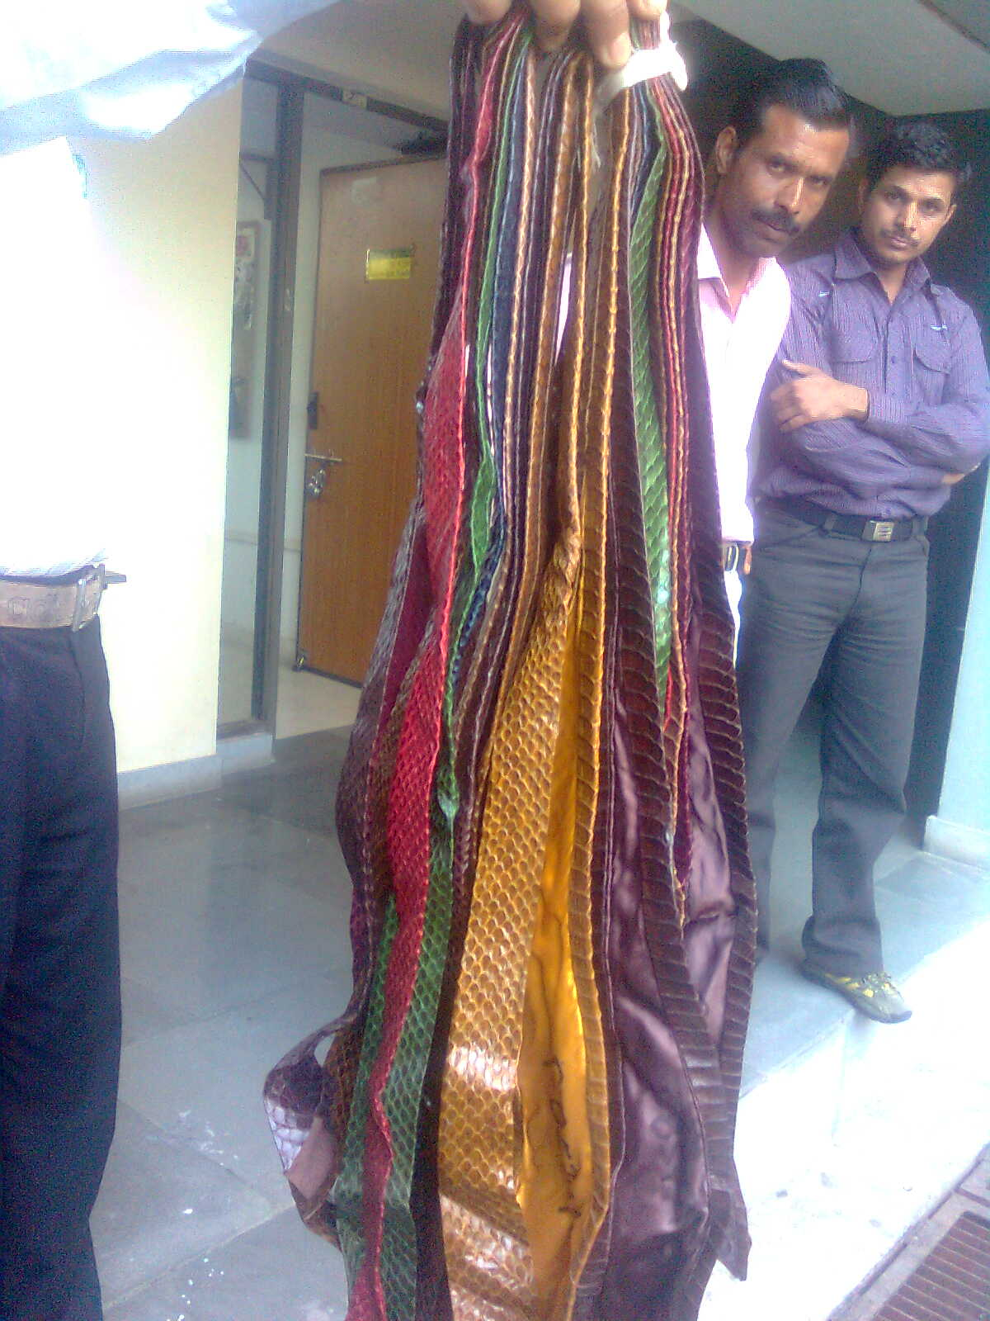

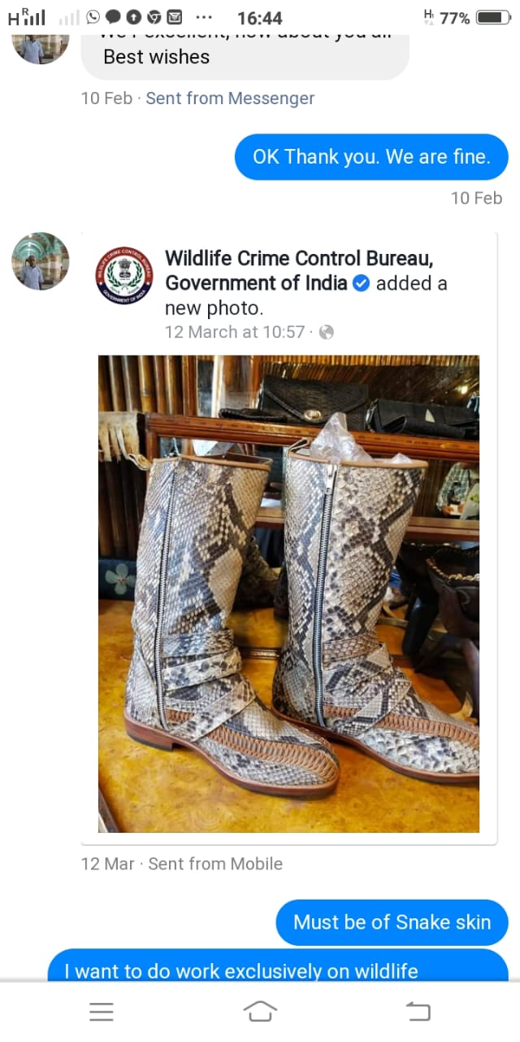

Fig 1.Shoes made up of reptile skin source WCCB

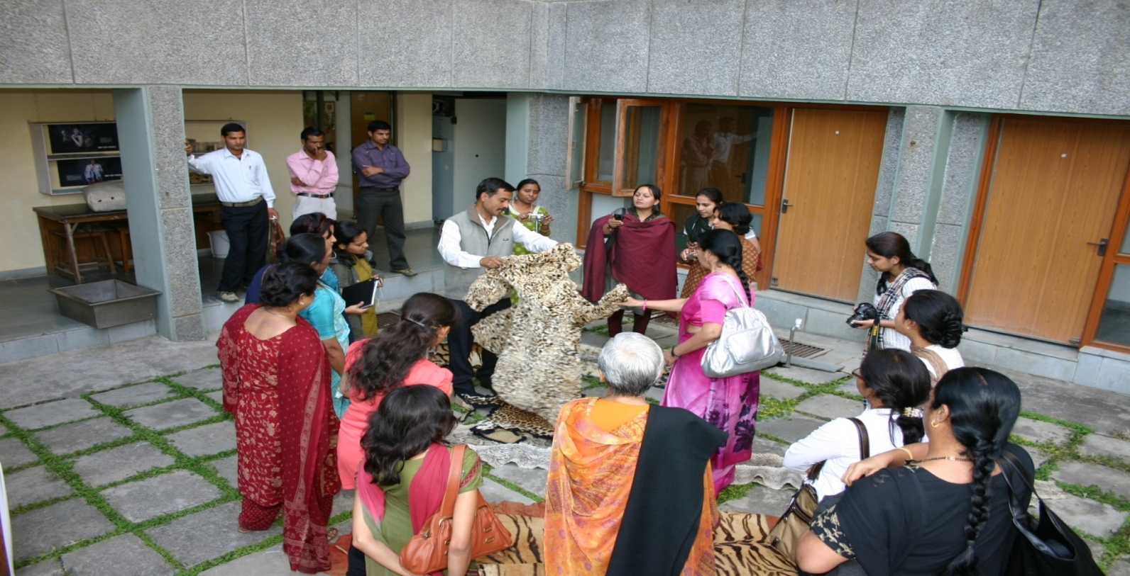

Fig 3.Ties made up of snake skin as received by Wildlife Institute of India

Fig 2 Fur coat made up of Snow leopard as received by Wildlife Institute of India

|  |  |  |
| --- | --- | --- |
| **WILDLIFE CRIME IN 2018** | | |
| **Species** | **Cases** | **percentage** |
| Leopard | 81 | 20.9% |
| Sheduled birds | 61 | 15.7% |
| Tiger | 42 | 10.8% |
| Star tortoise/turtle | 39 | 10.1% |
| Deer | 36 | 9.3% |
| Elephant | 27 | 7.0% |
| Snake | 19 | 4.9% |
| Rhino | 16 | 4.1% |
| Mongoose | 15 | 3.9% |
| Pangolin | 14 | 3.6% |
| Others | 38 | 9.8% |
| Total | 388 | 100% |

Table 1: Wildlife crime details of some faunal groups in 2018

Source: Ministry of Environment, Forest and Climate Change

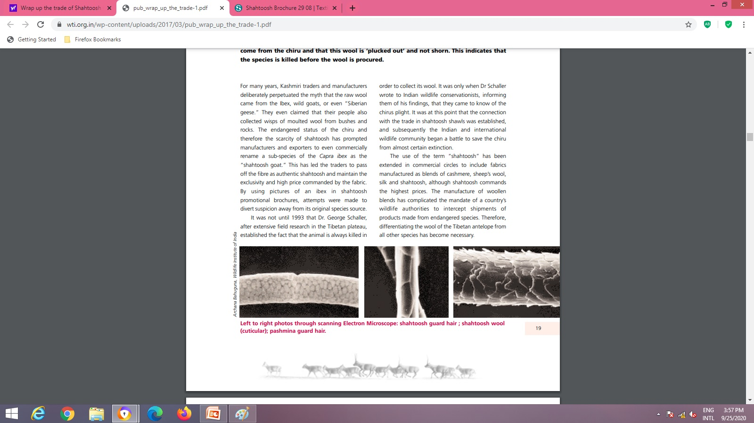

Figure 4. The first publication on identification of hair of Tibetan antelope by using guard hair by Bahuguna, Archana , Goyal, S.P. and Mukherjee S.K. in Wrap up the trade (a document published by IFAW International Fund for animal Welfare and Wildlife Trust of India, Wildlife Trust of India, New Delhi) and also in Science and Justice in 2000 indicating the unique features of guard hair of Tibetan antelope. .

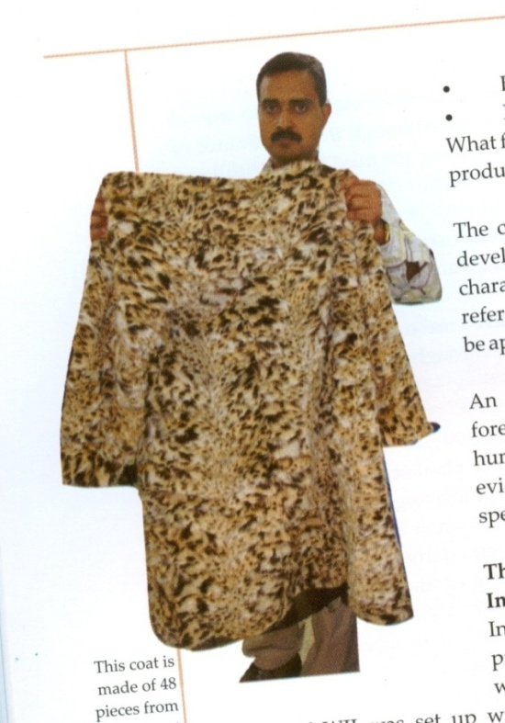**Dealing with fur coat cases**:

Figure 5. The coat is made of 48 pieces of skin from 4-5 species of small cats and after examining the coat by using Scanning Electron microscopy and also by using features of medulla, cross section features and also by cuticular examination, it was noted that the sleeves of the coat were made by using the leopard cat skin.

**(Source :** **Handbook on Wildlife Law Enforcement in India, TRAFFIC, WWF )**

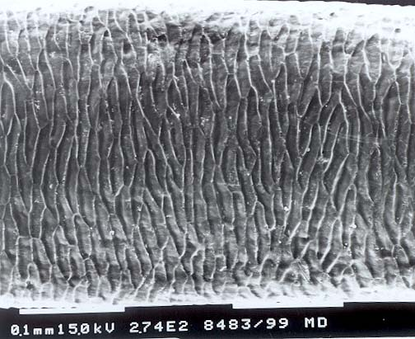

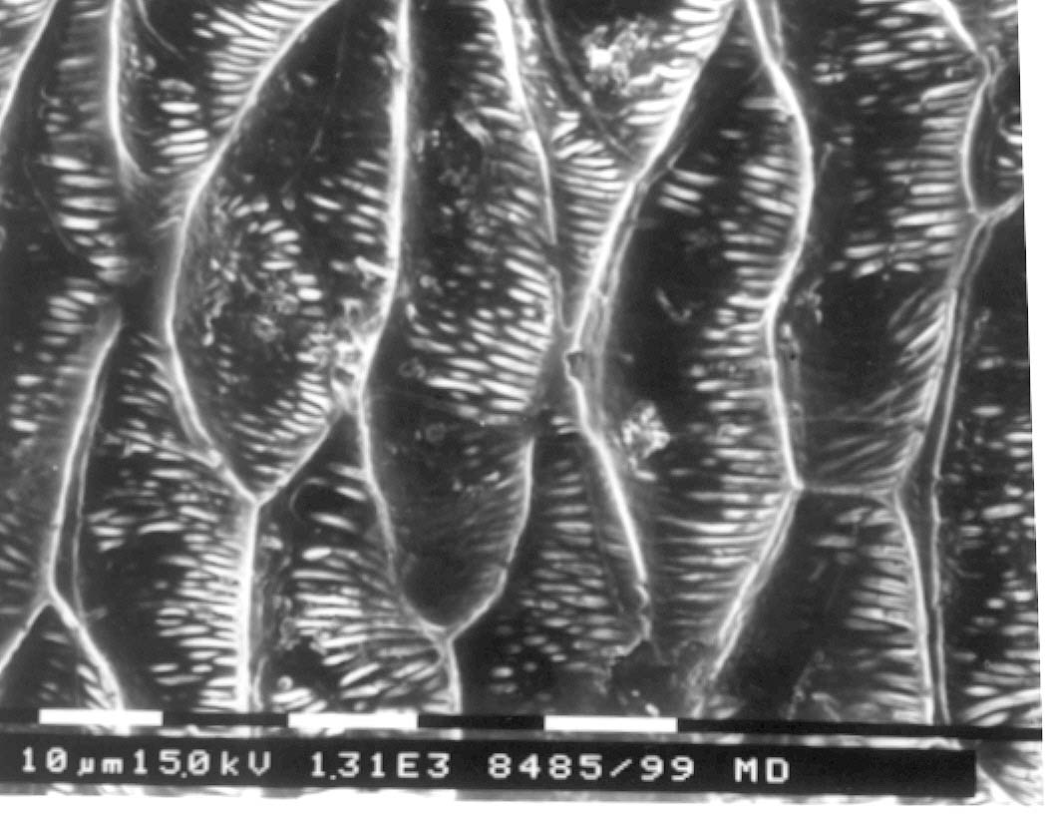

Figure 6. Figure 7

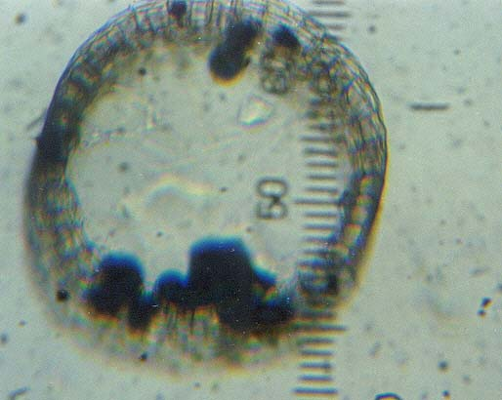

Figure 8

Figures 6,7 *Moschus chrysogaster*: Cuticular by using SEM: with characteristic lines seen on enlarges view of scales (Fig 7) and cross section of musk deer guard hair (Fig 15)

|  |  |  |  |  |  |
| --- | --- | --- | --- | --- | --- |
| **Species** | **External feature of hair** | **Medulla type** | **Cross section** | **Cuticular pattern** | **Scale index:** |
| ***Rusa unicolor*, Sambar** | **Beige ,Brown,thick** | **Wide medulla lattice**  **M/T 0.82** | **O,Lm** | **D to P**  **R, slightly crenate, near** | **D 4.6 ±0.0**  **P 4.5 ±0.0**  **M 6.12± 0.1** |
| ***Axis axis*, Chital** | **Beige, brown ,thin** | **Wide medulla lattice**  **M/T 0.87** | **O,C, Lm** | **D: R,Smooth,near**  **P: R,crenate,near**  **M:R,crenate,near** | **D 9.5 ±0.6**  **P 5.0 ±0.7**  **M 5.0 ±0** |
| ***Moschus chrysogaster*, Musk deer** | **Wavy & creamish** | **Wide medulla lattice**  **M/T 0.97** | **O,C,Lm** | **D to P**  **R,smooth,near** | **D 3.2 ±0.2**  **P 3.4± 0.6**  **M 3.3± 0.2** |

**Table 2. Comparative study of the PGH features**

**O : Oval, D: distal, P: proximal, M: middle R regular wave**

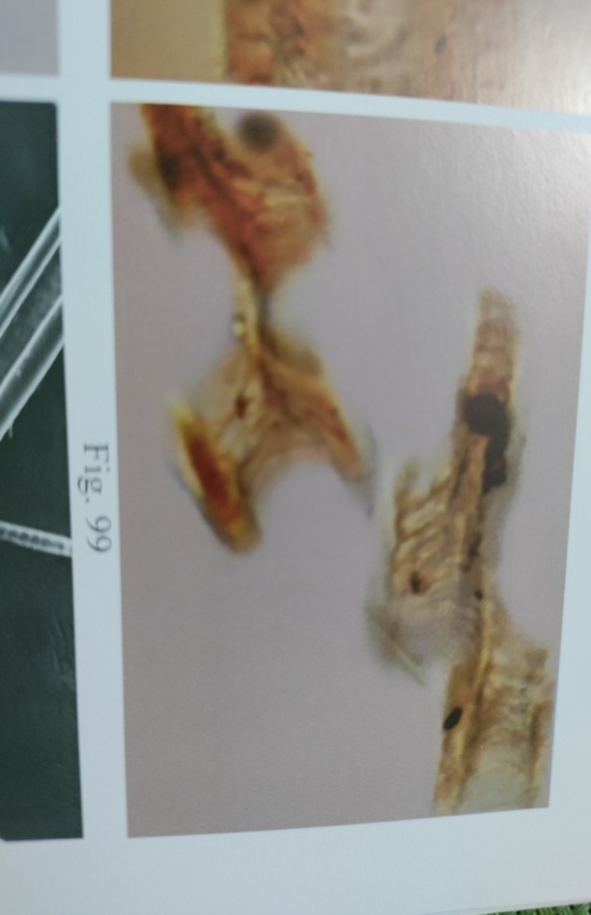

**Differentiating families of Lagomorpha**

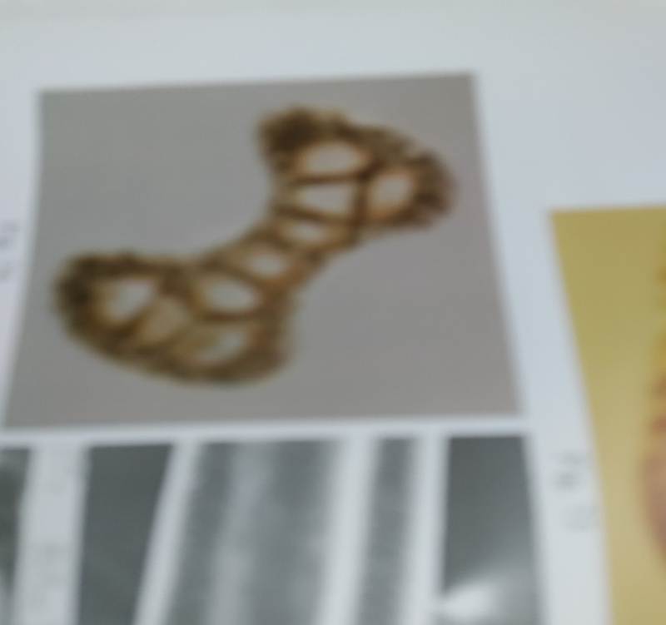

Fig 9 Cross section of Leporidae Fig 10 Cross section: Ochotonidae

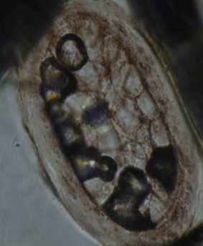**Cross section types: To study the hair fromm different body regions is necessary for the identification of the species**

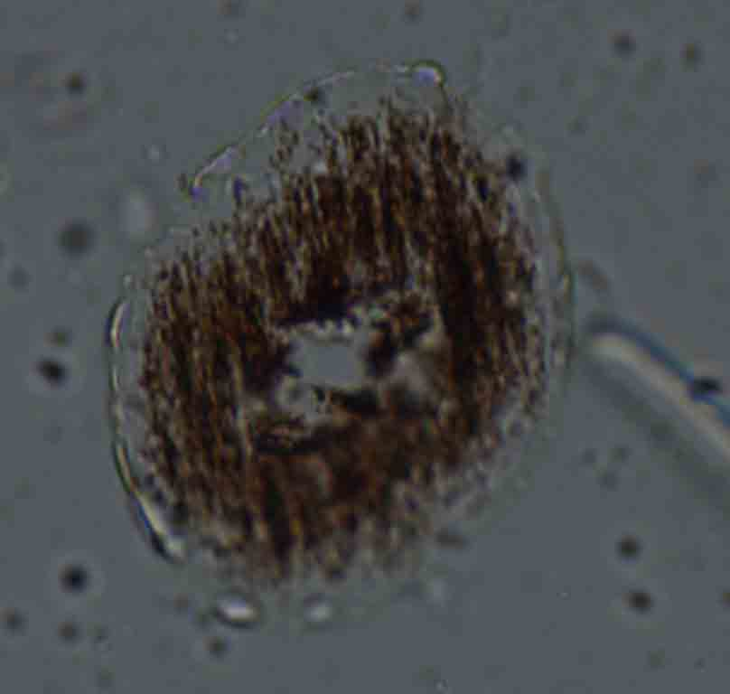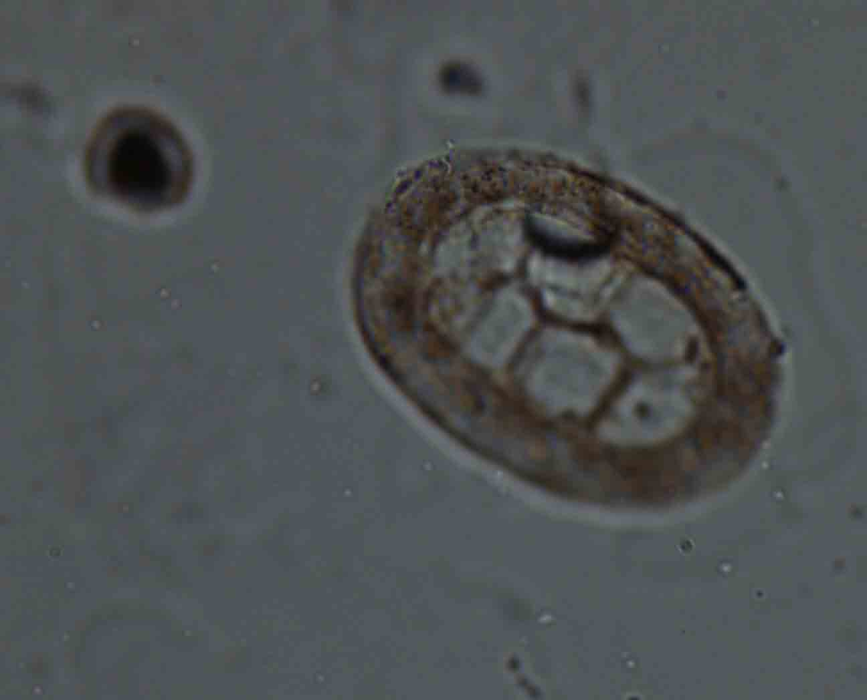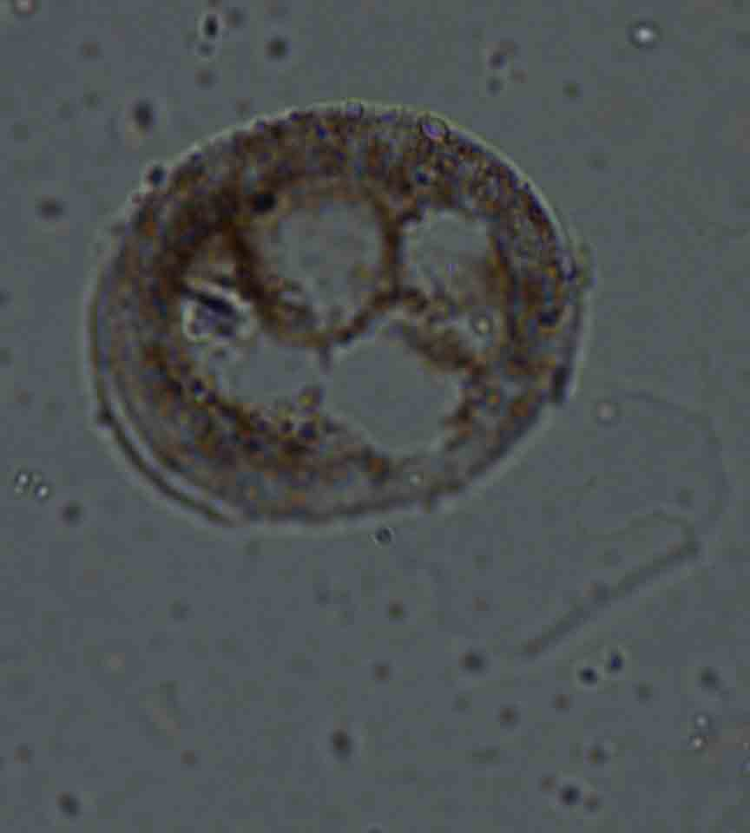

**Fig 11 Head Fig 12 Tail Fig 13 Ventral Fig 14 Dorsal**

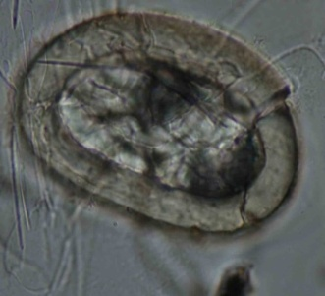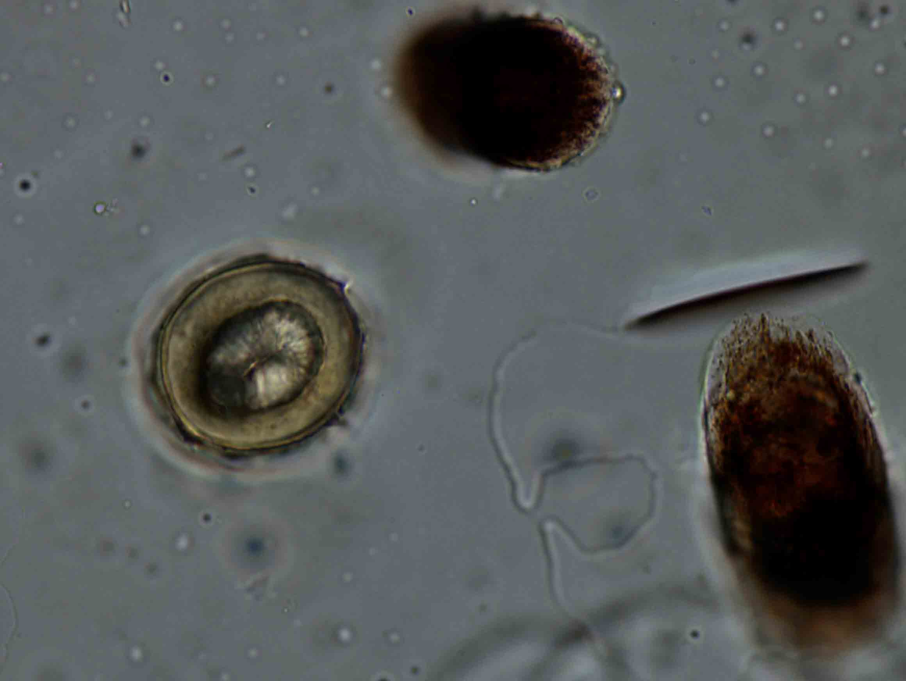***Cross section types of Paradoxurus hermaphroditus* (Pallas) (Figs 11-14)**

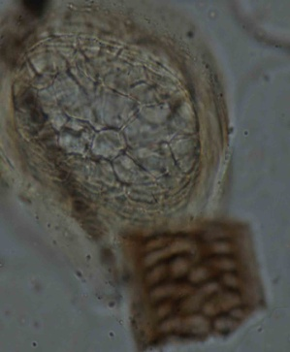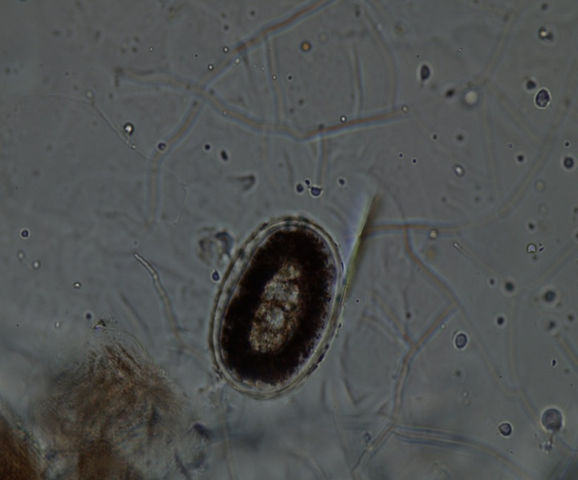

**Cross section types of *Viverra zibetha* Linn.**

**Fig 15 Head Fig 16 Tail Fig 17 Ventral Fig 18 Dorsal**

***Cross section types of Viverra zibetha* Linn.(Figs 15-18)**

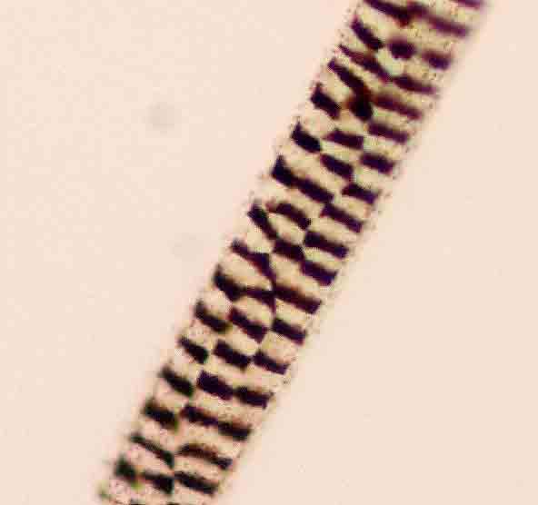 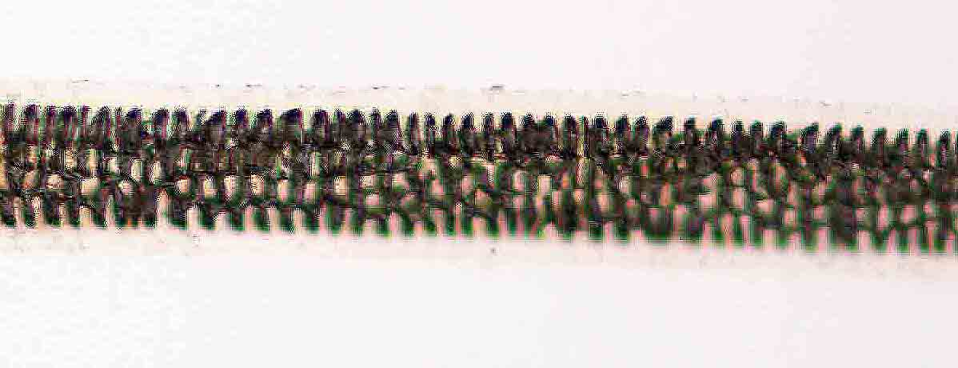

Figure 19 Figure 20

**Multiserial ladder medulla of species of squirrels (Figuress 19,20)**



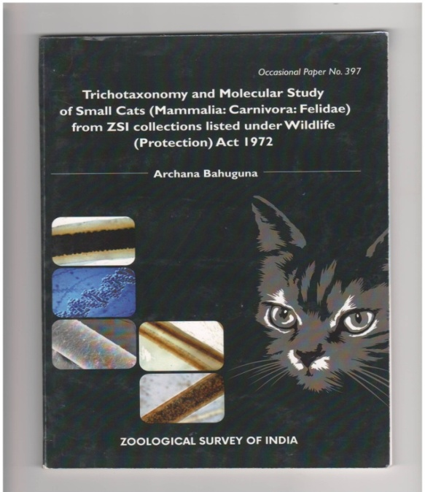

Figure 21 Some publications on trichotaxonomy by author

As it was noted that it is difficult to identify the species of cats based on tricho taxonomy thus molecular study was used to delimit the species of cats

Figure 22: Example of simple phylogenetic tree by **Maximum Likelihood method** (by using Cytochrome b gene). The evolutionary history was inferred by using the Maximum Likelihood method based on the Kimura 2 parameter model (Kumar 1980). There were a total of 1100 positions in the final dataset. Evolutionary analysis were conducted in MEGA 6 (Tamura et al. 2013)



Figure.23 Evolutionary relationships of taxa  by **Neighbour Joining method** (by using Cytochrome b gene).The evolutionary history was inferred using the Neighbor-Joining method [ Saitou N. and Nei M. (1987 )]. The evolutionary distances were computed using the Kimura 2-parameter method [Kimura,M 1980] and are in the units of the number of base substitutions per site. The analysis involved 7 nucleotide sequences. There were a total of 1100 positions in the final dataset. Evolutionary analyses were conducted in MEGA6 **.**

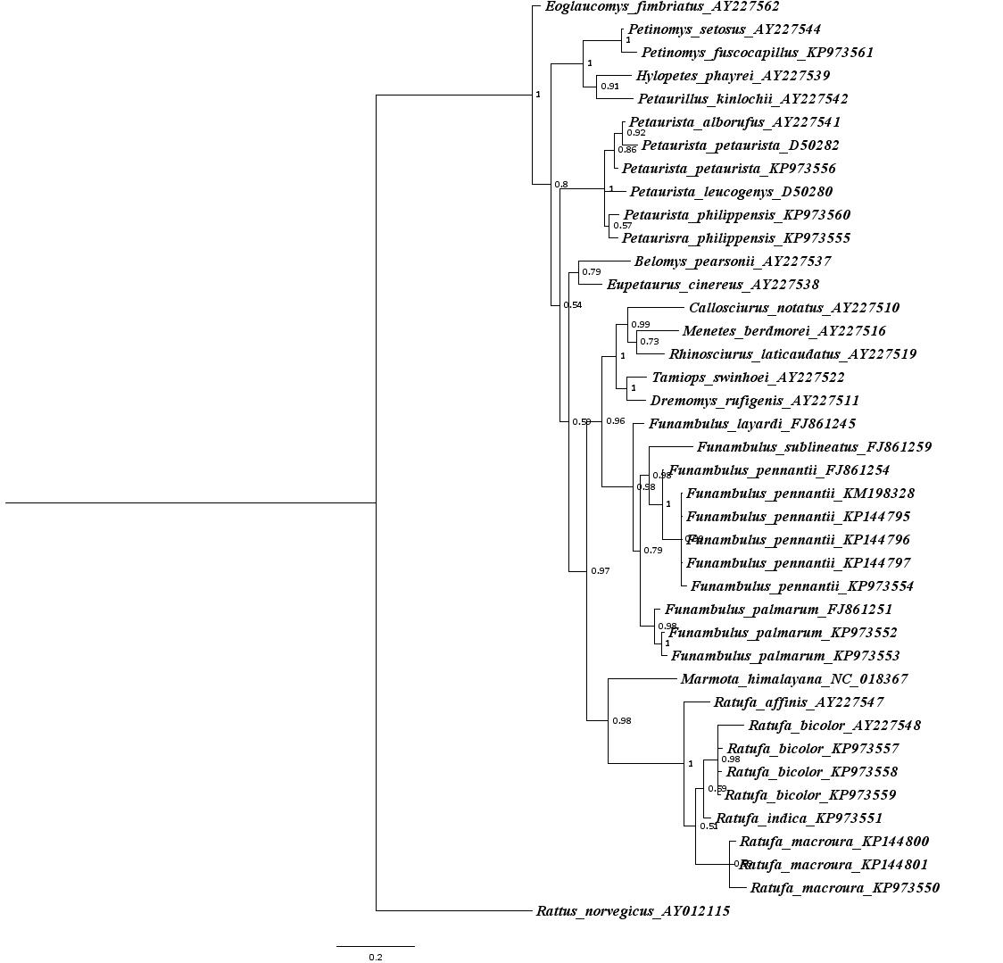

**Figure 24. Example of Plylogenetic tree based on 12srRNA genetic analysis of species of squirrels by using taxidermy sample as DNA source material.**

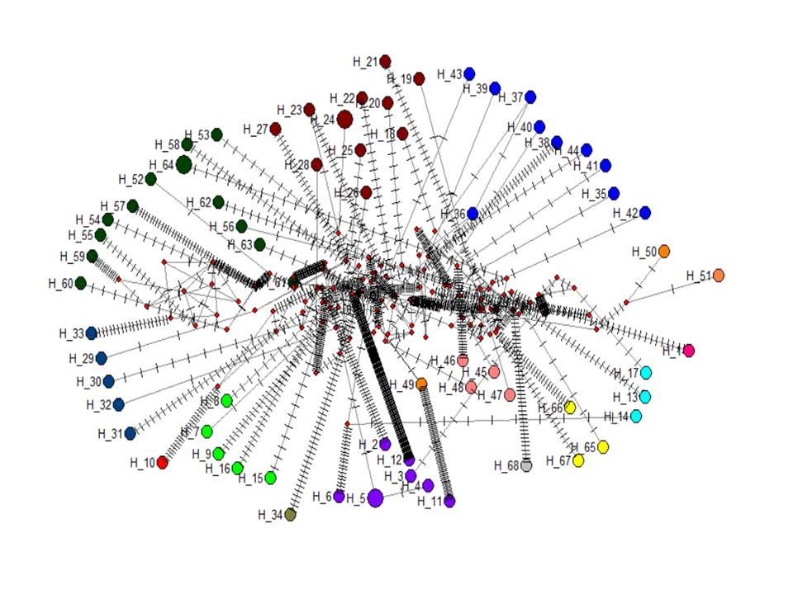

**Figure 25. Example for haplotype network: It helps in getting the information about the origin of species.**

Haplotype Network of 64 species belonging to 14 genus (Hap 1 *Marmorata*, Hap 2-6; 11,12 *Funambulus*, Hap 10 *Petinomys*,13,14,17 *Petaurista*, 7-9,1516 *Ratufa* ; 18-28 *Callosuirus*; 29-33 *Dremomys* ;34 *Exilisciurus;* 35-44 *Sundasciurus*; 45-48 *Tamiops*; 49-51 *Microsciurus*; 53-65 *Sciurus*, 66-68 *Tamiasciurus*, 68 *Eoglancomys*)of squirrels with mutated position lines and nodes are proportional to frequencies.

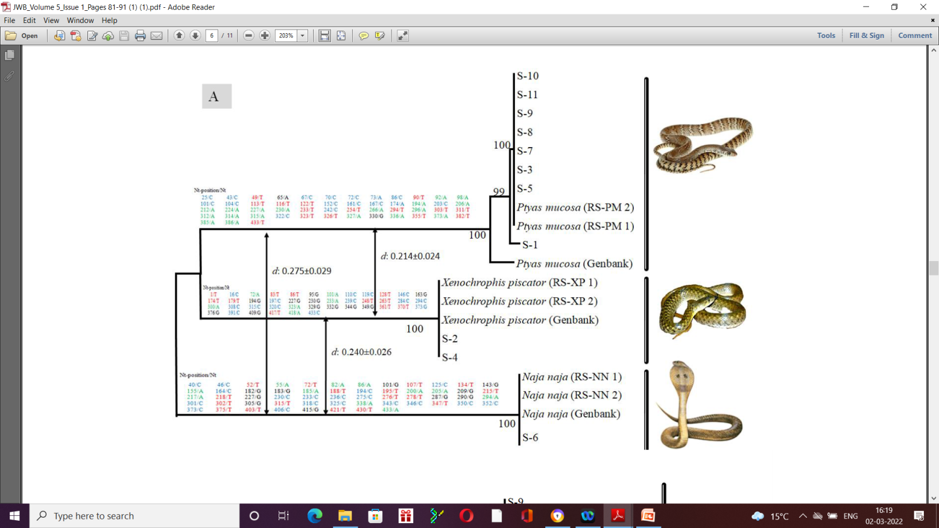

Figure 23 A non invasive genetic sampling approach to generate species specific gene sequences for snakes (Rajpoot et al.2021).

**Acknowledgement:** The author is grateful to US FWS for providing the opportunity to work in the field of Wildlife forensic as author started working in this field after being selected as Project Biologist in IndoWII-USFWS project on Wildlife forensic at Wildlife Institute of India. The author is grateful to Dr Dhriti Banerjee, Director, Zoological Survey of India for all support and encouragement for writing this small note for SWFS newsletter and also to Officer-in-Charge Dr Gaurav Sharma, Northern Regional Center, Zoological Survey of India, for the support.